In this video, we will discuss customizing datetime editor template. Please watch [Part 44](http://csharp-video-tutorials.blogspot.com/2013/06/part-44-display-and-edit-templated.html), before proceeding. We will be using the same example, that we worked with in [Part 44](http://csharp-video-tutorials.blogspot.com/2013/06/part-44-display-and-edit-templated.html).

At the moment, when you navigate to **localhost/MVCDemo/Home/Edit/1**, the output is as shown below.   
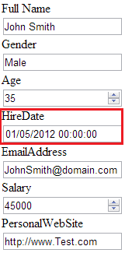

Notice that, for **HireDate**, users have to type in the date. Dates have got different formats. For example, **MM/DD/YYYY** or **DD/MM/YY** etc. So, different users may type it differently. Also, from a user experience, it is better to display a **DateTime** picker from which the user can simply select the date.  
  
The **built-in DateTime editor** template used by MVC, simply displays a textbox for editing Dates. So, let's customize the DateTime editor template, to use jQuery calendar. We want the output as shown below.  
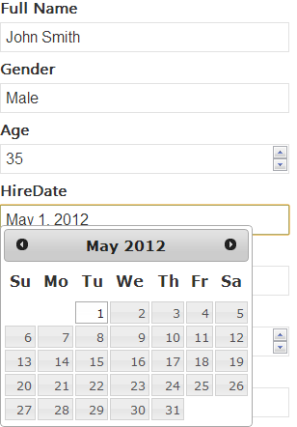   
  
**The following is the convention used by MVC to find the customized templates**  
**1.** The customized display templates must be in a sub-folder that is named - **DisplayTemplates**. Editor templates must be in a sub-folder that is named - **EditorTemplates**.

**2.** These sub-folders can live in **"Shared"** folder, or a specific views folder. If these folders are present in the Shared folder, then the templates are available for all the views. If they are in a specific views folder, then, they are available only for that set of views.  
**3.** The **name of the template** must match the **name of the type**. For example, as we are customizing DateTime template, the name of the template in this case has to be DateTime.ascx or DateTime.cshtml.  
  
**Adding a Custom DateTime Editor template**  
**Step 1:** If **"Shared"** folder does not already exists in your project, right click on the project in solution explorer and add it.  
  
**Step 2:** Right click on the **"Shared"** folder, and **"EditorTemplates"** folder.  
  
**Step 3:** Right click on **"EditorTemplates"** folder and add a view with **name = DateTime**  
  
**Step 4:** Copy and paste the following code in **DateTime.cshtml** partial view  
@model DateTime?  
@Html.TextBox("", (Model.HasValue ? Model.Value.ToString("dd/MM/yyyy") : string.Empty), new { @class = "date" })  
**Note:** Please refer to the following MSDN articel for all the DateTime format strings  
<http://msdn.microsoft.com/en-us/library/8kb3ddd4.aspx>  
  
**Step 5:** Copy and paste the following code in **Edit.cshtml** view  
@model MVCDemo.Models.Employee  
@{  
    ViewBag.Title = "Edit";  
}  
  
<h2>Edit</h2>  
  
<script src="~/Scripts/jquery-1.7.1.min.js" type="text/javascript"></script>  
<script src="~/Scripts/jquery-ui-1.8.20.min.js" type="text/javascript"></script>  
<link href="~/Content/Site.css" rel="stylesheet" type="text/css" />  
<link href="~/Content/themes/base/jquery.ui.all.css" rel="stylesheet" type="text/css" />  
  
<script type="text/javascript">  
    $(function()   
    {  
        $("input:text.date").datepicker(  
        {  
            dateFormat: "dd/mm/yy"  
        });  
    });  
</script>  
  
@using (@Html.BeginForm())  
{      
    @Html.EditorForModel()  
    <br />  
    <input type="submit" value="Save" />  
}  
  
**Note:** Please refer to the following jQuery link for DateTime format strings  
<http://jqueryui.com/resources/demos/datepicker/date-formats.html>

The following **jQuery scripts** and css files are required for **jQuery DateTime picker control.** However, these files may change depending on the version of jQuery you are working with.  
**Scripts/jquery-1.7.1.min.js**  
**Scripts/jquery-ui-1.8.20.min.js**  
**Content/Site.css**  
**Content/themes/base/jquery.ui.all.css**